Mauritius: Ameenah Gurib-Fakim resigns over credit card scandal
According to her lawyer, the president will leave office on March 23 after scandal involving use of an NGO credit card.
17 Mar 2018
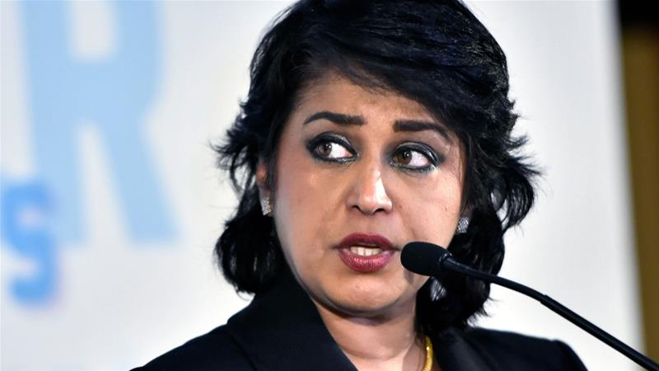
President of Mauritius Ameenah Gurib-Fakim said she used a credit card issued by an NGO she was involved with accidentally for personal items [File: Zoltan Mathe/The Associated Press]

Mauritian President Ameenah Gurib-Fakim has resigned after allegations of credit card fraud, according to local media.
Gurib-Fakim's lawyer made the announcement on Saturday, telling reporters that she will leave office on March 23.
Gurib-Fakim has been accused of buying jewellery and clothing using a credit card provided by an NGO, founded by an Angolan banker interested in doing business in Mauritius.
Last week, Gurib-Fakim said she would not leave office despite Prime Minister Pravind Jugnauth announcing she would resign.
In a response to that announcement, the office of Gurib-Fakim, whose role as president is mostly ceremonial, released a statement detailing that she would remain in office.
"Her Excellency Ameenah Gurib-Fakim, having nothing to feel guilty about and able to provide corroborating evidence, rejects any idea of resigning," that statement read.
"She is also willing to go to court to defend herself against the slanderous accusations against her."
The allegations against the president, who is also a renowned biologist, stem from her joining the London-based Planet Earth Institute (PEI) in 2015 in an effort to further develop the scientific field in Africa.
In 2016, she received a credit card from PEI to pay for travel and other expenses related to her work for the organisation.
Gurib-Fakim, 58, allegedly used the credit card to buy items worth $26,000 not related to her work for PEI.
Gurib-Fakim claimed the use of the NGO credit card for these expenses was purely accidental, saying she used the PEI credit card because she also owned a personal credit card from the same bank.
This allegedly led her to accidentally mix up the two cards.
Gurib-Fakim said she paid back any money she owed PEI and any other logistical expenses linked to her role.
That claim was confirmed by PEI in a public statement, in which the organisation also said Gurib-Fakim had resigned from PEI.
However, it was not just the expenses but Gurib-Fakim's general involvement with PEI that raised eyebrows in Mauritius.
PEI was founded by Alvaro Sobrinho, an Angolan businessman whose efforts to set up enterprises in Mauritius have come under scrutiny.
Sobrinho is being investigated in Switzerland and Portugal for alleged fraud.
In 2017, he was allowed to set up an investment bank in Mauritius, which prompted critics to accuse the government of playing favouritism.
Gurib-Fakim was president since May 2015. Before she became president, she worked as a world-renowned biologist, winning several awards for her work and her importance as a woman in the scientific field.

